Another successful Easter Show
Ian Morphett Myall Koala & Enviroment Group| April 2015

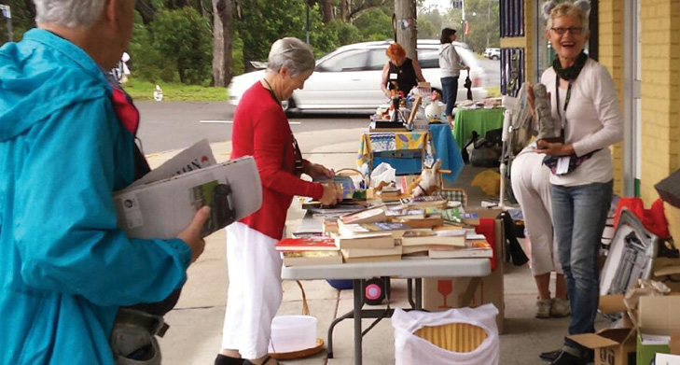
Despite the rain, hundreds of locals and visitors browsed the stalls under the canopy of Hugo’s Newsagency on Yamba Street.
Volunteer Adrienne Ingram
Staffed by 10 volunteers, the event raised a total of $1,765 from the sale of raffle tickets, home-baked cakes, books and trash and treasure.
The money will be used to improve the corridors used by our locally endangered koalas, enhancing the environment for many other birds and animals.
The President of the Myall Koala Environment Group Jill Madden said, “It was fantastic result and great fun on a wet day, thanks to everyone.”
The raffle winners were Mark (Ticket Purple B84), Dee (Purple A07), Pearl (Purple B73) and Gae (Red F42).
Thank you to Myall Coast Fitness, Gwenda Collins, Jill and Peter Madden and Koree Farm for providing the prizes.

