Cakes give Easter sale egg-stra boost
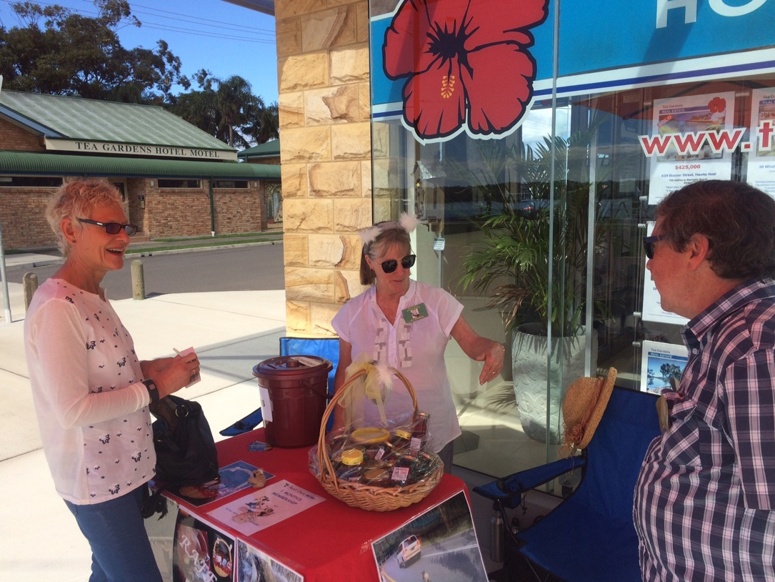
Adrienne Ingram Myall Koala & Environment Group | April 2017
Figure 1Volunteers Adrienne Ingram, Jill & Peter Madden

An SOS went out from volunteers at the annual Easter koala stall in Hawks Nest when they ran out of cakes to sell.

Demand for the home-baked cakes was so great that the Myall Koala and Environment Group sold out within the first hour and had to make urgent calls to members and friends to bring more.

The sun, locals and visitors came out to support the koala stall in Hawks Nest on Easter Saturday.

As well as the cakes, the fundraiser outside Hawks Nest Newsagency and Post Office offered bric-a-brac, books, CDs, DVDs, costume jewellery, potted plants, electrical items and toys donated and collected by the group and supporters.

The raffle was also a success with prizes of wine, a month’s membership for the Myall Fitness Gym from Ann Woods, a koala backpack and a big basket of Koree Farm products from Helmut Panhuber. Two of the winners have been informed, Graeme Street and Jane Raftesath. The other two winners donated their prizes back to the group and there will be a re-draw.

The fundraiser made $1,337 overall, with $703 from the raffle, $529 from bric-a-brac and $105 from the cakes.

Ian Morphett, Secretary of The Myall Koala & Environment Group, thanked all the helpers on the day and all the goods that members and friends donated.

