Celebrating Bushcare’s Big Day Out
Adrienne Ingram Bitou Buster | 2019
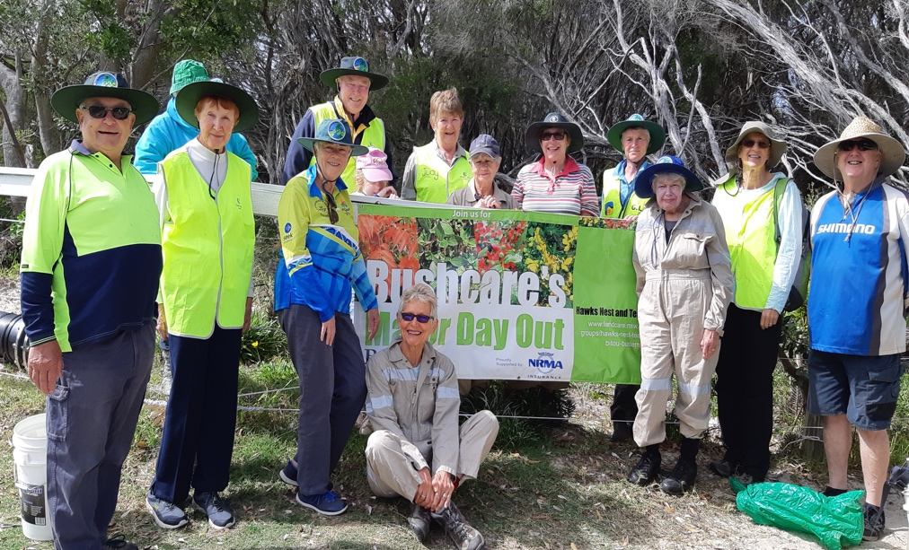
Another great Saturday morning’s work by seventeen Bitou Buster volunteers who helped to improve the dunes at Jimmys Beach.
This group was one out of 250 bush care sites across Australia Celebrating Bushcare’s Big Day Out, a day to restore and maintain Australia’s remaining bushland.
Hard, difficult work continued, dealing with the bitou bush on the dunes. More pig face planting on the dunes was carried out which has been a great success.

And finally, but not least, the removal of millions of those mothers of millions toxic weeds kept everyone busy. Thirty bags were full of the weeds for the volunteers to take to their red rubbish bins.

The group welcomed a new volunteer Jane Holtom and we were assisted by seven-year-old Lucy, granddaughter of members Trish and Gordon Blair

