Easter stall back after COVID crisis
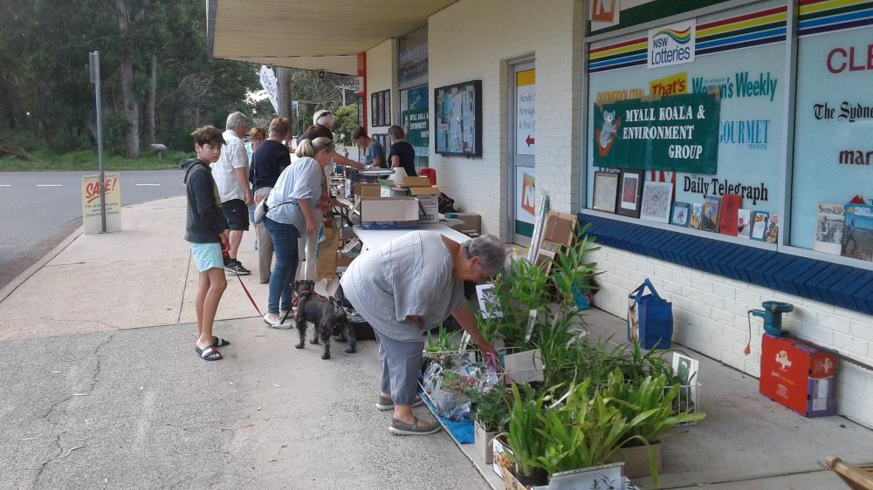
Adrienne Ingram Myall Koala & Environment Group | April 2021
The Myall Koala & Environment Group annual Easter fundraising stall returned to Hawks Nest after the COVID crisis.
The stall was cancelled last year at the height of the pandemic and lockdowns in NSW.
Locals and visitors helped Myall Koala Environment Group volunteers to raise almost $1,800 at their annual fundraiser and Easter stall in Hawks Nest. That included $1,114 from the sale of raffle tickets. Organisers said more people than ever visited the stall outside Hugo’s Newsagency.
“It was bigger and better than before,” said the group’s president, Richard Streamer. “There were lots of great bargains and plenty of bric-a-brac for everyone.”
He explained that the Easter stall and raffle are the major events to generate money for the group’s voluntary work protecting wildlife in the Myall area.
“We have several exciting projects planned for this year that need funding,” he said.

