Fighting Jimmys Beach Erosion
Adruenne Ingram Bitou Buster | 2019
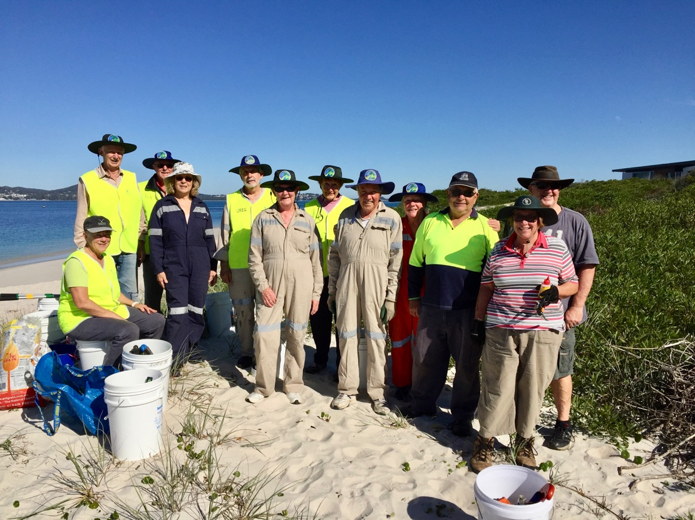
Local Bitou Busters have been playing their part in fighting the erosion at Jimmys Beach by working to re-establish native vegetation on the dunes.
Sixteen Bitou Busters worked on a section of the beach, east of Barnes Rock where some vegetation remains but is still under threat.
To help stabilising the beach, they cleared invasive weeds such as bitou to give native plants a chance to flourish.
Amongst the weeds were coastal wattle and four nodding greenhood orchids which were rescued from the clutches of the noxious weed bitou.
Pig face was also planted in areas that were cleared helping to bind the sand.
Bitou Busters coordinator Jill Madden said, “There are not many dunes left behind Jimmys Beach at Winda Woppa so anything the volunteers can do to save the remaining dunes is vital in protecting the peninsula.’’

