Koala Easter stall great success
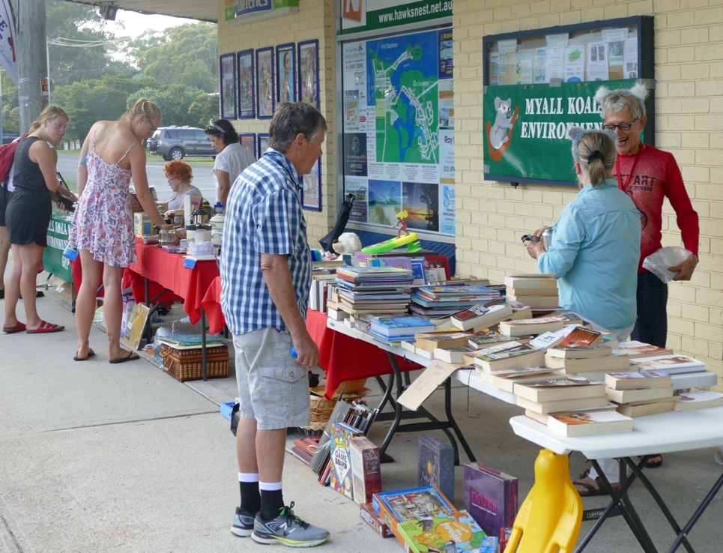
Ian Morphett Myall Koala & Environment GROUP APRIL 2019
Despite the forecast for “occasional showers”, there was not a cloud all morning and it became quite hot in the blazing sunshine, which was a bit hard on our stall helpers and some of the merchandise.
Volunteers Peter & Jill Madden with Adrienne Ingram

This year, merchandise sales were fantastic and significantly higher than last year. This year our sales were $934.55 compared to $632.75 last year (cake sales included in both figures). We must thank everyone who donated items for sale or baked cakes and slices. The quality of items this year was exceptionally high. THANK YOU.

Raffle ticket sales on the day were up on last year despite the Family Research Group also selling raffle tickets outside the newsagents. This year $402.35, last year $261.00. However, overall, raffle sales were down due to one day in March being a complete washout and Tea Gardens sales not being particularly good. Overall, this year $759.40, last year $1,114.35 (Jill & Peter had one fantastic day in HN of over $400).

In total our sales this year were $1,693.95 compared to $1,787.50 and last year was the best for the preceding three years. So all-in-all a wonderful result!

This will go towards further fauna surveys around town and to support habitat rehabilitation.

Thank you to a great team of enthusiastic helpers this year who did a fantastic job.

