Take-away koala food a great success
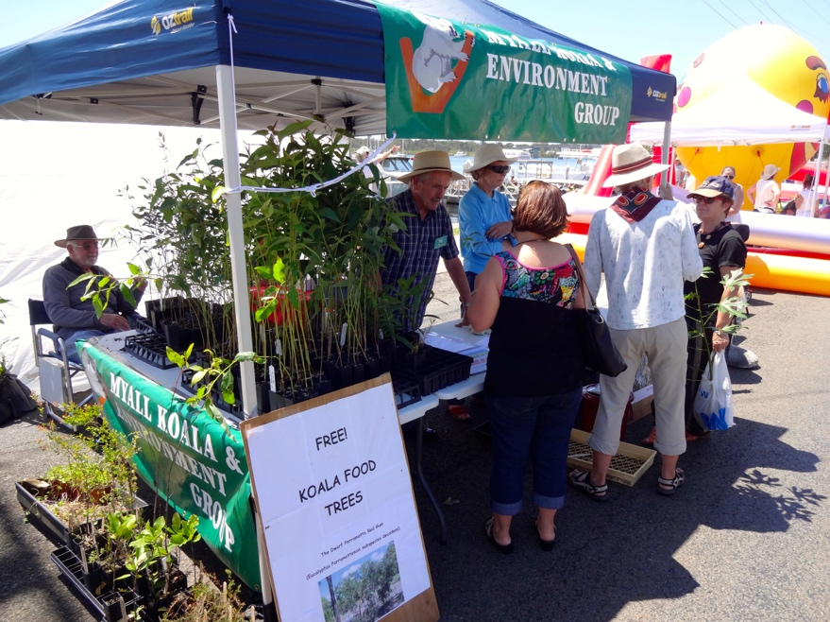
Adrienne Ingram Myall Koala & Environment Group | October 2014

Volunteers gave away 400 koala food trees and native shrubs to people attending the Myall River Festival.
Great Lakes Council gave Myall Koala and Environment Group 400 seedlings of trees liked by koalas and 150 native bush plants to attract birds and these were gratefully received by people with properties and gardens mainly in the Tea Gardens and Hawks Nest area, but some from as far away as Newcastle.

The trees ranged from swamp mahogany and dwarf red gum, the preferred koala food trees plus rainforest shrubs and native plants.

Myall Koala and Environment Group shared a stall with the local Bitou Busters and Land for Wildlife.
They gave advice planting their new trees, handed out leaflets and encouraged people to report koala sightings.
Kim the big koala was a huge success with children and adults alike, enjoying having their photos taken.
The group also enrolled a number of new members on the day.
It was a good day for everyone to be more aware of their environment and to help the bush and wildlife to survive and grow.

