Wildside festival a Hugh success
Ian Morphett Author | October 2015

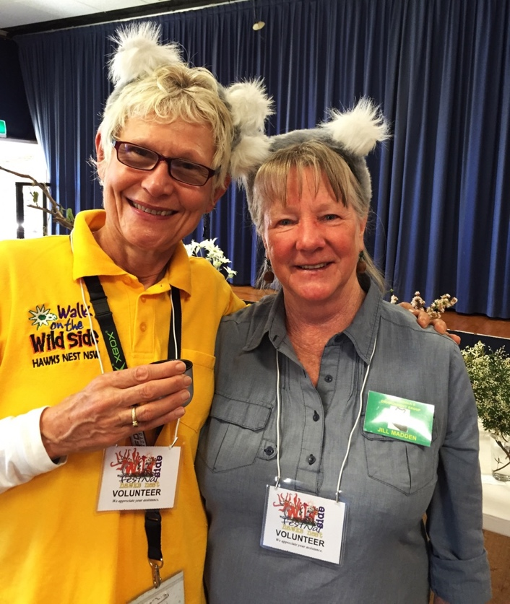
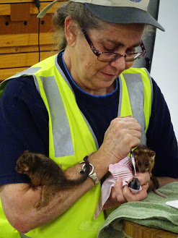
Adrienne Ingram, Jill Madden
Katrina Gray NPWS feeding baby possum
In its tenth year, the Wildside Festival was perhaps its most successful yet.
For a start, the weather on the Friday, Saturday and Sunday was absolutely perfect with balmy temperatures, cloudless skies and very little wind.
On Friday evening Christian Patteson had nearly 40 spotlighting walkers who were all thrilled that he was able to find a koala for them.
Saturday saw stalls and activities all around the Hawks Nest Community Hall. All stalls reported good sales and many visitors. The Lionesses, Red Cross Ladies and Newcastle Native Plant Society had excellent sales. Lee Anderson’s face painting, Katrina Gray’s NPWS stall, the RFS fire engine, Leigh Allen’s kids craft stall and, of course, the Big Koala had droves of children supporters all day long. The Arts and Crafts, Visitor Information Centre stalls and GLC Isabelle Strachan’s water catchment display had lots of interest.
The talks in the Old Library about koalas, “What weed is that?” and wildlife rescue were well attended. NATF’s Jill Dean’s baby possum and squirrel glider feeding was the hit of the day with small children and their parents. GLC Terry Inkson’s weed identification walk (8), Christian Patteson’s Koala spotting walk (23) where a baby koala was seen and Jill Madden’s Michael Rowe Memorial Wildflower walk (27) all had great participation.
On Sunday 19 people went on Anne Haskew’s Swan Bay Bush Tucker and Wildflower walk, and 12 were at the Bushcare Major Day Out.

